**JAVA SWING BASED**

**CONSULTANCY SERVICES FOR JOB HUNT**

**-SQL**  **CONNECTIVITY USING JDBC**

*A*

*Report*

*Submitted in partial fulfilment of the*

*Requirements for the award of the Degree of*

***BACHELOR OF TECHNOLOGY***

***IN***

**INFORMATION TECHNOLOGY**

By

**SHREYA.CHEPURI <1602-20-737-040>**

**Under the Guidance of**

**B. Leelavathy**



**Department of Information Technology****Vasavi College of Engineering (Autonomous)**

**(Affiliated to Osmania University)**

**Ibrahimbagh, Hyderabad-31**

**2021-2022**

# BONAFIDE CERTIFICATE

This to Certify that the project report titled

**“CONSULTANCY SERVICES FOR JOB HUNT”** project work of Ms. Shreya Chepuri bearing Roll.no:1602-20737-040who carried out this project under my supervision in the IV semester for the academic year 2021-2022.

*Signature*   *Signature*   *external examiner internal examiner*

ROLL NO: 1602-20-737-040

NAME: Shreya Chepuri [2]

**ABSTRACT:**

In the current scenario, there is a rat race in each and every professional field. It is also true for job market. Job consultancy is a website dedicated for online information about recruiters as well as job seekers. A job consultancy helps both the job seekers and recruiters finding the right organization for the employees. In the case of job seekers, according to their educational qualification, experience and their preferences, the job consultancy portal shows the list of companies to the job seeker. And, to the recruiters, provides the suitable candidates from a pool of lacks. The objective of this application is to develop a system to enable interaction between employers and applicants. The determination is to allow communication between the interested parties and complete the task of recruitment quickly.

ROLL NO: 1602-20-737-040

NAME: Shreya Chepuri [3]

**REQUIREMENT ANALYSIS:**

**LIST OF TABLES:**

## • Admin • Job seeker • Job category • Job info • Application details

**LIST OF ATTRIBUTES WITH THEIR DOMAIN TYPES:**

**Admin:**

|  |  |
| --- | --- |
| Admin_id | number(5) |
| username | varchar2(20) |
| password | varchar2(2) |

## Name varchar2(20) Email varchar2(50)

Contact number(10) **Job seeker:**

|  |  |
| --- | --- |
| Applicant_id | number(5) |
| name | varchar2(20) |
| username | varchar2(20) |
| password | varchar2(20) |
| Gender | varchar2(20) |
| Email | varchar2(50) |
| Contact | number(10) |
| Qualification | varchar2(20) |
| Skills | varchar2(40) |

**Job Recruiter:**

Recruiter_id number(5)

|  |  |
| --- | --- |
| Name | varchar2(20) |
| Username | varchar2(20) |
| Password | varchar2(20) |
| Email | varchar2(50) |
| Contact | number(10) |
| Website | varchar2(20) |

**Job Category:**

Admin_id number(5)

Category_id number(5)

Category_Name varchar2(20)

|  |  |  |
| --- | --- | --- |
| **Job information:**  Job_Id |  | number(5) |
| Title |  | varchar2(20) |
| Description |  | varchar2(20) |
| Company_id |  | number(5) |
| Category_id |  | number(5) |
| Job_type |  | varchar(20) |
| Job_salary |  | number(10) |
| Posting_date |  | date() |
| Last_application_date |  | date() |
| No_of_vacancy |  | number(5) |
| Job_status |  | varchar2(20) |
| **Application_details:** |  |  |
| Applicantion_id |  | number(5) |
| Applicant_id |  | number(5) |
| Job_id |  | number(5) |
| Application_status |  | varchar2(10) |

**ER DIAGRAM:**

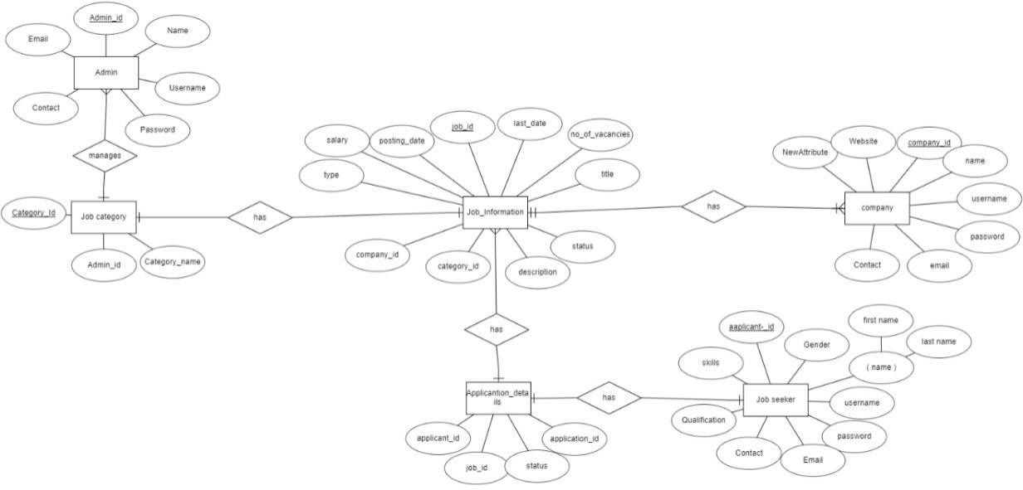

**RELATIONAL MODEL:**

**DDL OPERATIONS:**

**Admin:**

## create table Admin(admin_id number(5),username varchar2(20),password varchar2(20),name varchar2(20),email varchar2(20),contact number(10));

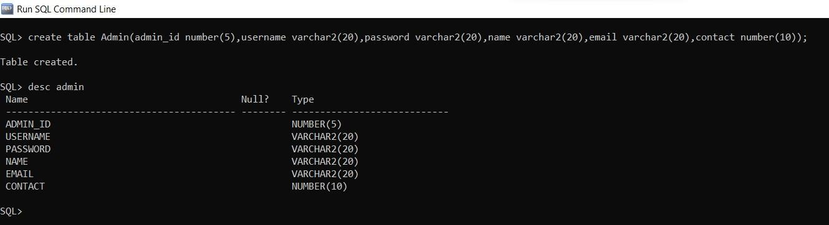

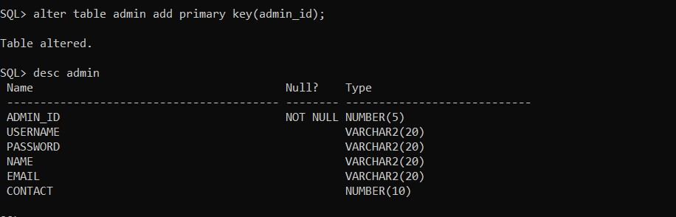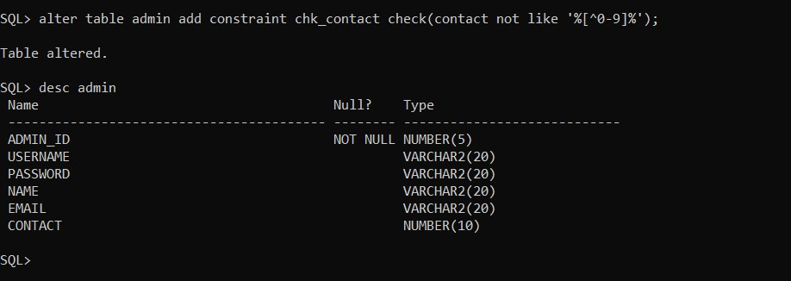

**Job seeker:**

## create table jobseeker(applicant_id number(5),username varchar2(20),password varchar2(20),name varchar2(20),email varchar2(20),contact number(10),gender varchar2(20),qualification varchar2(20),skills varchar2(40),primary key(applicant_id));

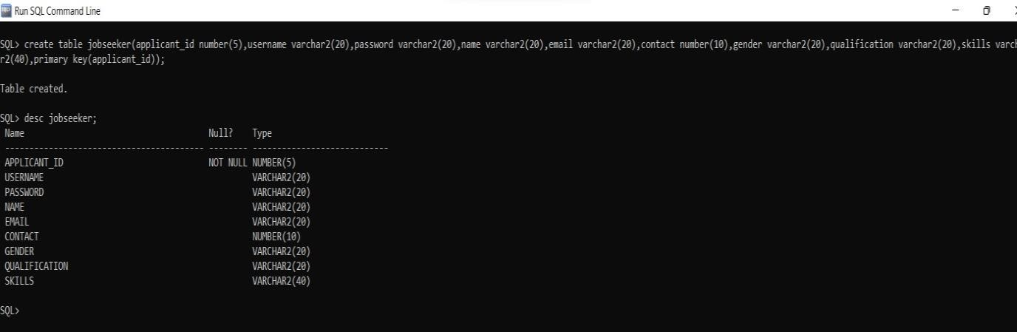

**Company/job recruiter:**

create table company(company_id number(5),username varchar2(20),password varchar2(20),name varchar2(20),email varchar2(20),contact number(10),website varchar2(20),primary key(company_id));

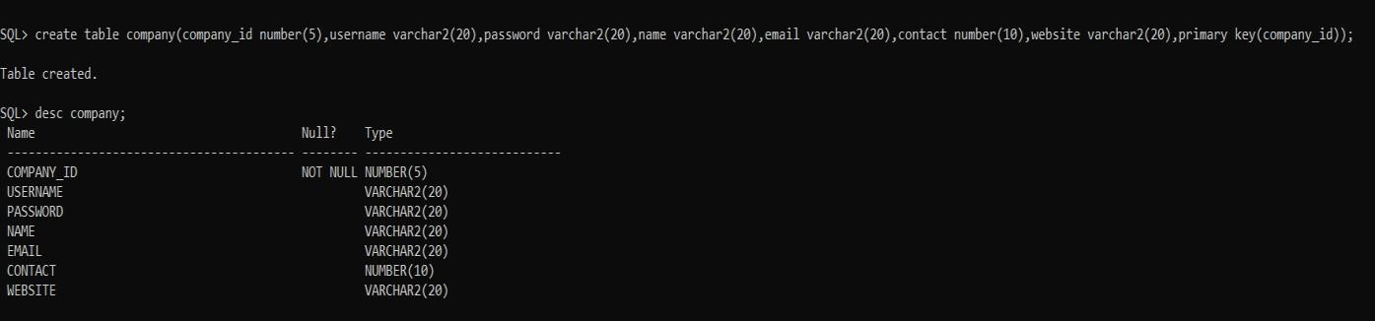

**Job_category:**

## create table job_category(category_id number(5),category_name varchar2(20),primary key(category_id));

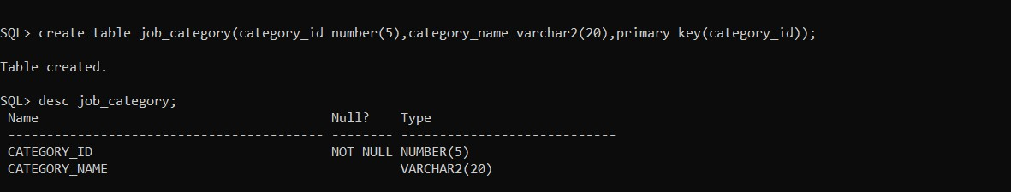

## alter table job_category add foreign key(admin_id) references admin;

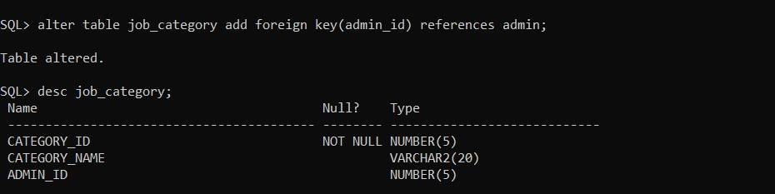

**Job information:**

create table job_information(job_id number(5),job_title varchar2(20),job_description varchar2(20),category_id number(5),company_id number(5),type varchar2(20),salary varchar2(20),posting_date date,last_date date,no_of_vacancies number(5),status varchar2(20),primary key(job_id),foreign key(category_id) references job_category,foreign key(company_id) references company);

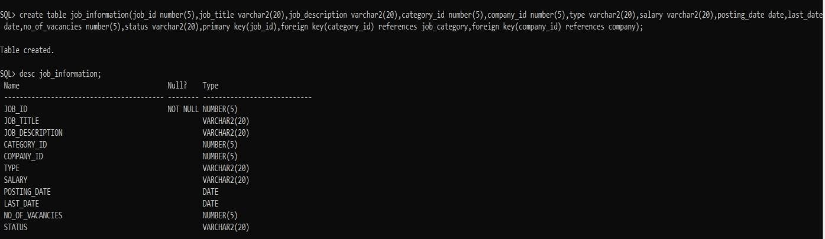

**Application_details:**

create table application_details(application_id number(5),applicant_id number(5),job_id number(5),foreign key(job_id) references job_information,foreign key(applicant_id) references jobseeker,primary key(application_id));

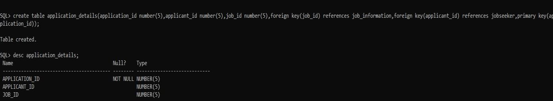

**DML OPERATIONS:**

**Admin:**

## insert into admin values(101,'shreya_chepuri','admin123','shreya','shreya.chepuri@14.gmail.com',9381798920 );

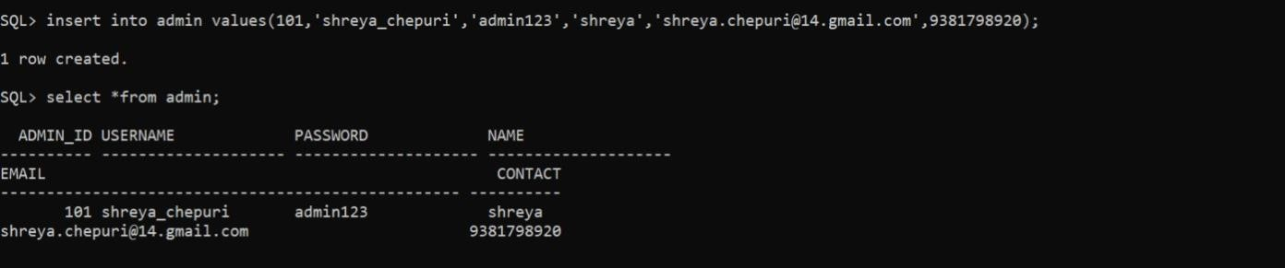

**Jobseeker:**

## insert into jobseeker values(&applicant_id,'&username','&password','&name','&email',&contact,'&gender','&qual ification','&skills')

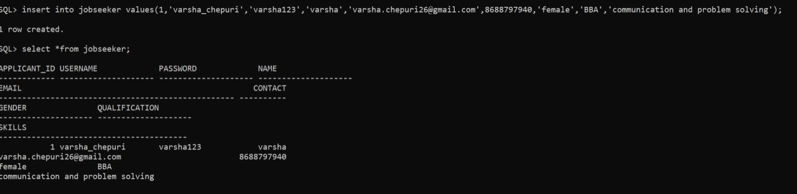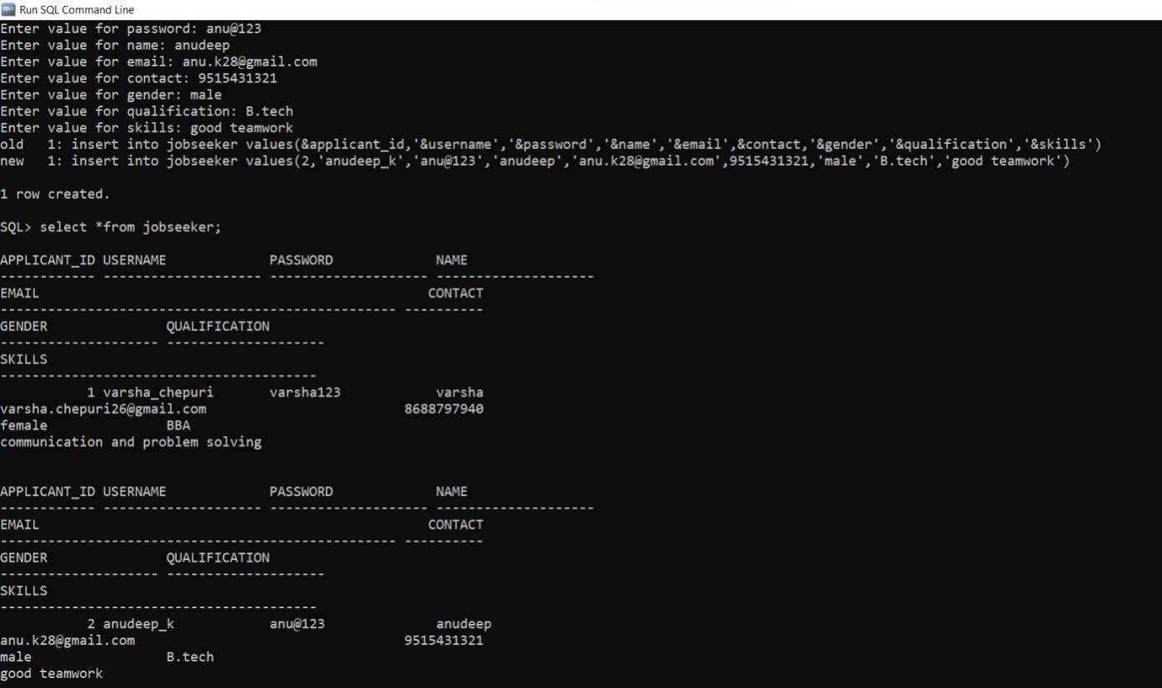

**Company:**

## insert into company values(&company_id,'&username','&password','&name','&email',&contact,'&website')

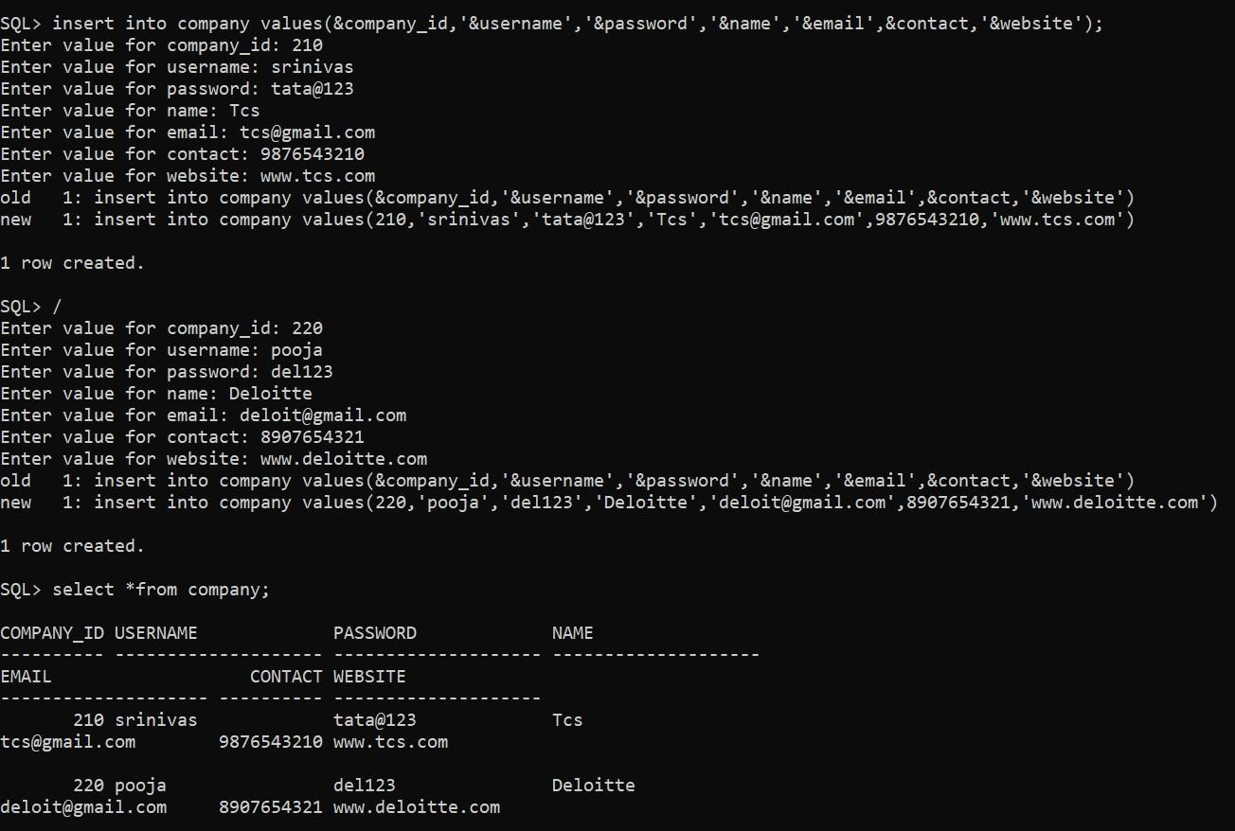

**Job category:**

## insert into job_category values(&category_id,'&category_name',&admin_id);

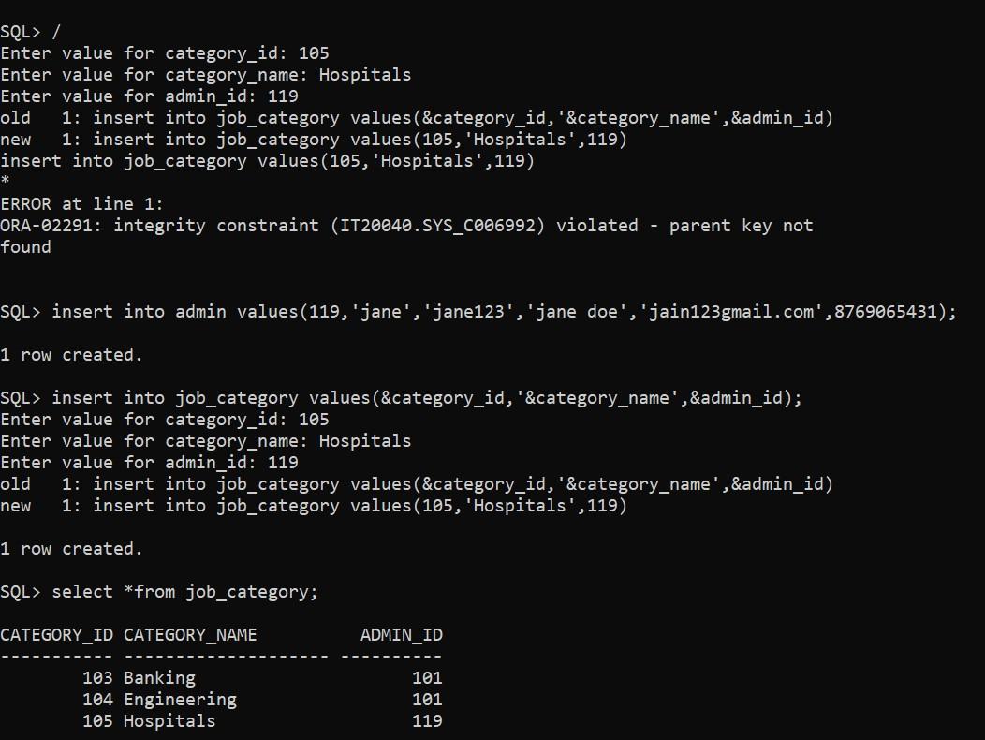

**Job Information:**

## insert into job_information values(&job_id,'&job_title','&job_description',&category_id,&company_id,'&type',&salary,' &posting_date','&last_date',&no_of_vacancies,'&status');

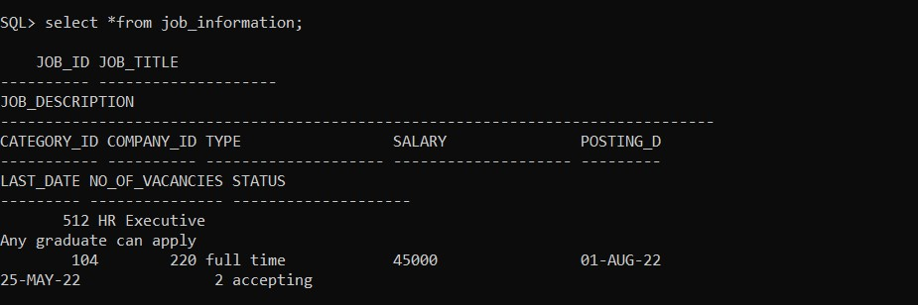

**Application_details;**

## insert into application_details values(1001,1,512);

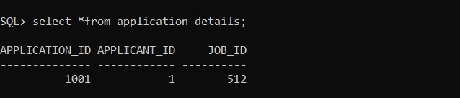

**Implementation:**

Front end programs and its connectivity Java Database Connectivity (JDBC) is an application programming interface (API) for the programming language Java, which defines how a client may access a database. It is a Java-based data access technology used for Java database connectivity. It is part of the Java Standard Edition platform, from Oracle Corporation. It provides methods to query and update data in a database and is oriented towards relational databases. The connection to the database can be performed using Java programming (JDBC API) as:

public void connectToDB()

{ try

{

connection

=

DriverManager.getConnection("jdbc:oracle:thin:@localhost:1521:xe","shreya","vasavi123"); statement = connection.createStatement();

}

catch (SQLException connectException)

{

System.out.println(connectException.getMessage())

;

System.out.println(connectException.getSQLState()

);

System.out.println(connectException.getErrorCode());

System.exit(1);

}

}

Thus, the connection from Java to Oracle database is performed and therefore, can be used for updating tables in the database directly.

**Program:**

MainPage:

import javax.swing.*; import java.awt.*; import java.awt.event.*; public class MainPage extends JFrame{

private JFrame frame= new JFrame(); private JLabel lable = new JLabel();

private JLabel l1 = new JLabel("NEW USER??"); private JButton b1=new JButton("REGISTER"); private JLabel l2 = new JLabel("EXISTING USER!!"); private JButton b2=new JButton("LOGIN"); private JButton b3=new JButton("LOGIN AS ADMIN");

private JMenuBar mBar;

private JMenu mnuHelp; private JMenuItem abt;

public MainPage(){

frame.setTitle("Home Page"); frame.setLayout(null); frame.setDefaultCloseOperation(JFrame.EXIT_ON_CLOSE); frame.setBounds(100,150,1000,900);

Container c=frame.getContentPane(); frame.getContentPane().add(b1); frame.getContentPane().add(b2); frame.getContentPane().add(l1); frame.getContentPane().add(l2); frame.getContentPane().add(b3);

initializeMenuBar();

frame.setJMenuBar(mBar);

abt.addActionListener(new HelpMenuActionListener()); JLabel label=new JLabel("CONSULTANCY SERVICES FOR JOB HUNT");

label.setBounds(200,5,700,50); label.setFont(new Font("Serif",Font.PLAIN,30)); lable.setIcon(new ImageIcon("C:/Users/ANUDEEP/Downloads/Dbms/job.jpg"));

lable.setBounds(10,7,600,600);

l1.setBounds(700,100,170,40);

b1.setBounds(700,150,170,40); b1.setFont(new Font("Times New Roman",Font.BOLD,17)); l2.setBounds(700,200,170,40); b2.setBounds(700,250,170,40); b2.setFont(new Font("Times New Roman",Font.BOLD,17)); b3.setBounds(680,320,220,40); b3.setFont(new Font("Times New Roman",Font.BOLD,17));

b1.addActionListener(new ActionListener() {

public void actionPerformed(ActionEvent ae) {

new HomePage1();

}

});

b2.addActionListener(new ActionListener() { public void actionPerformed(ActionEvent ae) {

new Login();

}

});

b3.addActionListener(new ActionListener() {

public void actionPerformed(ActionEvent ae) {

new AdminLogin();

}

});

c.add(label);

c.add(lable);

frame.setVisible(true);

}

public void initializeMenuBar()

{ mBar=new JMenuBar(); mnuHelp=new JMenu("Help"); abt=new JMenuItem("About"); mnuHelp.add(abt); mBar.add(mnuHelp);

}

private class HelpMenuActionListener implements ActionListener { public void actionPerformed(ActionEvent ae) {

if(ae.getSource()==abt)

{

String details;

details = "This project is to enable interactions between employers and applicants"+"\n"+

"It has 2 main tables:"+"\n"+

"1.Admin and Jobseeker"+"\n"+

"2.Admin further accessed to adding a recruiter and viewing the Recruiter List and Userlist"+"\n"+

"3.JobSeeker accessed with profile and jObslist";

JOptionPane.showMessageDialog(null,details,"INFORMATION", JOptionPane.INFORMATION_MESSAGE);

}

}

}

public static void main(String args[]){

new MainPage()

}

}

import javax.swing.*; import java.awt.*; import java.awt.event.*; public class HomePage1 extends JFrame{ private JFrame frame= new JFrame(); private JButton b2=new JButton("Job seeker"); private JButton b3=new JButton("Recruiter"); private JMenuBar mBar; private JMenu mnuHelp; private JMenuItem abt;

public HomePage1(){

frame.setTitle("Home Page"); frame.setLayout(null); frame.setDefaultCloseOperation(JFrame.EXIT_ON_CLOSE); frame.setBounds(100,150,1000,400);

Container c=frame.getContentPane(); frame.getContentPane().add(b2); frame.getContentPane().add(b3); initializeMenuBar();

frame.setJMenuBar(mBar);

abt.addActionListener(new HelpMenuActionListener()); JLabel label=new JLabel("CONSULTANCY SERVICES FOR JOB HUNT");

label.setBounds(200,5,700,50);

JLabel lable=new JLabel("REGISTER AS:"); lable.setBounds(200,100,700,50);

label.setFont(new Font("Serif",Font.PLAIN,30));

b2.setBounds(300,150,170,40); b2.setFont(new Font("Times New Roman",Font.BOLD,17)); b3.setBounds(500,150,170,40); b3.setFont(new Font("Times New Roman",Font.BOLD,17));

b2.addActionListener(new ActionListener() {

public void actionPerformed(ActionEvent ae) {

frame.dispose(); new RegistrationForm();

}

});

b3.addActionListener(new ActionListener() { public void actionPerformed(ActionEvent ae) { new RegistrationForm_Rec();

}

});

c.add(label);

c.add(lable);

frame.setVisible(true);

}

public void initializeMenuBar()

{ mBar=new JMenuBar(); mnuHelp=new JMenu("Help"); abt=new JMenuItem("About"); mnuHelp.add(abt); mBar.add(mnuHelp);

}

private class HelpMenuActionListener implements ActionListener { public void actionPerformed(ActionEvent ae) {

if(ae.getSource()==abt)

{

String details;

details = "This project is to enable interactions between employers and applicants"+"\n"+

"It has 2 main tables:"+"\n"+

"1.Admin and Jobseeker"+"\n"+

"2.Admin further accessed to adding a recruiter and viewing the Recruiter List and Userlist"+"\n"+

"3.JobSeeker accessed with profile and jObslist";

JOptionPane.showMessageDialog(null,details,"INFORMATION", JOptionPane.INFORMATION_MESSAGE);

}

}

}

public static void main(String args[]){

new HomePage1();

}

}

## **Table: Admin**

AddRecruiter:

import java.awt.*; import java.awt.event.ActionEvent; import java.awt.event.ActionListener; import java.sql.*; import javax.swing.*;

public class AddRecruiter1

{

JFrame frame = new JFrame("Insert");

JLabel heading = new JLabel("ADD RECRUITER");

JLabel Rid = new JLabel("Recruiter ID : "); JLabel user = new JLabel("User Name :");

JLabel ps = new JLabel("Password : ");

JLabel comp = new JLabel("Company Name: ");

JLabel email = new JLabel("Email : ");

JLabel web = new JLabel("Website : ");

JLabel cont = new JLabel("Contact : ");

JLabel go_to = new JLabel("GOTO");

JTextField tfId = new JTextField();

JTextField tfuserName = new JTextField();

JPasswordField tfps = new JPasswordField();

JTextField tfcompName = new JTextField();

JTextField tfem = new JTextField();

JTextField tfweb = new JTextField();

JTextField tfcont = new JTextField(); JTextArea resultText = new JTextArea();

JButton home = new JButton("Home");

JButton insert = new JButton("Submit");

JButton back = new JButton("Back");

PreparedStatement stmt;

public AddRecruiter1(){

heading.setBounds(50, 50, 100, 20); Rid.setBounds(50, 100, 130, 30); user.setBounds(50, 150, 200, 30); tfId.setBounds(250, 100, 150, 30); tfuserName.setBounds(250, 150, 150, 30); ps.setBounds(50, 200, 150, 30); tfps.setBounds(250, 200, 150, 30);

tfps.setEchoChar('*');

comp.setBounds(50, 250, 150, 30); tfcompName.setBounds(250, 250,150, 30); email.setBounds(50, 300, 150, 30); tfem.setBounds(250, 300, 150, 30); web.setBounds(50, 350, 150, 30); tfweb.setBounds(250, 350, 150, 30); cont.setBounds(50, 400, 150, 30); tfcont.setBounds(250, 400, 150, 30); resultText.setBounds(250, 450, 200, 150);

insert.setBounds(50, 450, 100, 30); go_to.setBounds(50, 500, 100, 30); home.setBounds(50, 550, 100, 30); back.setBounds(50, 600, 100, 30); frame.add(heading); frame.add(Rid); frame.add(user); frame.add(tfId); frame.add(tfuserName); frame.add(ps); frame.add(tfps); frame.add(comp); frame.add(tfcompName); frame.add(email); frame.add(tfem); frame.add(web); frame.add(tfweb); frame.add(cont); frame.add(tfcont); frame.add(insert); frame.add(go_to); frame.add(home); //frame.add(resultText); frame.add(back);

frame.setLayout(null); frame.setVisible(true); frame.setBounds(10, 10, 500, 700); frame.setDefaultCloseOperation(JFrame.HIDE_ON_CLOSE); frame.setResizable(false);

insert.addActionListener(new ActionListener() {

public void actionPerformed(ActionEvent ae) {

try {

Connection

con=DriverManager.getConnection("jdbc:oracle:thin:@localhost:1521:xe","shreya","vasavi123");

PreparedStatement stmt=con.prepareStatement("insert into Addrecruiter values(?,?,?,?,?,?,?)");

if(tfId.getText()=="");

{

JOptionPane.showMessageDialog(new JFrame(),"Please Insert values!","NOTICE",JOptionPane.INFORMATION_MESSAGE);

}

stmt.setInt(1,Integer.parseInt(tfId.getText())); stmt.setString(2,tfuserName.getText()); stmt.setString(3,tfps.getText()); stmt.setString(4,tfcompName.getText()); stmt.setString(5,tfem.getText()); stmt.setString(6,tfweb.getText()); stmt.setInt(7,Integer.parseInt(tfcont.getText()));

int i=stmt.executeUpdate();

if(i>0)

{

JOptionPane.showMessageDialog(new JFrame(),"Successfully Inserted!","NOTICE",JOptionPane.INFORMATION_MESSAGE);

}

/*System.out.println(i + "records inserted");

resultText.append("Inserted" + i + "rows successfully"); */

con.close();

}

catch(SQLException e){

System.out.println€

}})

home.addActionListener(new ActionListener() { public void actionPerformed(ActionEvent ae) { frame.dispose(); new HomePage1();

}});

back.addActionListener(new ActionListener() { public void actionPerformed(ActionEvent ae) { frame.dispose(); new Admin1();

}});

}

}

Jobs_Seeker_list:

import javax.swing.*; import java.awt.*; import java.awt.event.*; import javax.swing.table.*; import java.sql.*; public class Job_List_seeker extends JFrame {

DefaultTableModel model = new DefaultTableModel();

JFrame frame = new JFrame();

JTable jtbl = new JTable(model);

public Job_List_seeker() { frame.setLayout(new FlowLayout(FlowLayout.LEFT)); model.addColumn("Job ID"); model.addColumn("Job title"); model.addColumn("Job Description"); model.addColumn("Category ID"); model.addColumn("Company ID"); model.addColumn("Type");

model.addColumn("Salary"); model.addColumn("Posting Date"); model.addColumn("Last Date"); model.addColumn("No of Vacancies"); model.addColumn("Status");

jtbl.setAutoResizeMode(JTable.AUTO_RESIZE_OFF); jtbl.getColumnModel().getColumn(0).setPreferredWidth(70); jtbl.getColumnModel().getColumn(1).setPreferredWidth(100); jtbl.getColumnModel().getColumn(2).setPreferredWidth(150); jtbl.getColumnModel().getColumn(3).setPreferredWidth(90); jtbl.getColumnModel().getColumn(4).setPreferredWidth(70); jtbl.getColumnModel().getColumn(5).setPreferredWidth(150); jtbl.getColumnModel().getColumn(6).setPreferredWidth(100); jtbl.getColumnModel().getColumn(7).setPreferredWidth(150); jtbl.getColumnModel().getColumn(8).setPreferredWidth(190); jtbl.getColumnModel().getColumn(9).setPreferredWidth(70); jtbl.getColumnModel().getColumn(10).setPreferredWidth(190);

String dburl ="jdbc:oracle:thin:@localhost:1521:xe";

String us = "shreya"; String pas ="vasavi123";

try {

Connection conn=DriverManager.getConnection(dburl,us,pas);

System.out.println("Connected");

PreparedStatement pstm = conn.prepareStatement("SELECT * FROM Job_information"); ResultSet Rs = pstm.executeQuery(); while(Rs.next()){

model.addRow(new Object[]{Rs.getInt(1),

Rs.getString(2),Rs.getString(3),Rs.getInt(4),Rs.getInt(5),Rs.getString(6),Rs.getInt(7),Rs.getDate(8),Rs.getDate(9),R s.getInt(10),Rs.getString(11)});

}

} catch (Exception e) {

System.out.println(e.getMessage());

}

JScrollPane pg = new JScrollPane(jtbl);

JButton apply = new JButton("APPLY"); pg.setBounds(10,10,2000,300);

frame.add(pg);

apply.setBounds(50,350,150,50);

frame.add(apply);

frame.setLayout(null);

frame.setVisible(true); frame.setBounds(10, 10, 600, 600); frame.setDefaultCloseOperation(JFrame.HIDE_ON_CLOSE); frame.setResizable(true);

pg.createHorizontalScrollBar(); pg.createVerticalScrollBar(); this.pack();

apply.addActionListener(new ActionListener() { public void actionPerformed(ActionEvent ae) {

try {

int row=jtbl.getSelectedRow();

String job_id = jtbl.getModel().getValueAt(row,0).toString();

String job_title = jtbl.getModel().getValueAt(row,1).toString();

String job_description =

jtbl.getModel().getValueAt(row,2).toString();

String cat_id = jtbl.getModel().getValueAt(row,3).toString();

String comp_id = jtbl.getModel().getValueAt(row,4).toString();

String type = jtbl.getModel().getValueAt(row,5).toString();

String salary = jtbl.getModel().getValueAt(row,6).toString();

String posting_date = jtbl.getModel().getValueAt(row,7).toString();

String last_date = jtbl.getModel().getValueAt(row,8).toString();

String no_of_vac = jtbl.getModel().getValueAt(row,9).toString();

String status = jtbl.getModel().getValueAt(row,10).toString();

Connection conn=DriverManager.getConnection(dburl,us,pas);

System.out.println("Connected");

PreparedStatement stmt = conn.prepareStatement("insert into Applied_Job_List values(?,?,?,?,?,?,?,?,?,?,?)");

stmt.setInt(1,Integer.parseInt(job_id));

stmt.setString(2,job_title); stmt.setString(3,job_description); stmt.setInt(4,Integer.parseInt(cat_id)); stmt.setInt(5,Integer.parseInt(comp_id)); stmt.setString(6,type); stmt.setInt(7,Integer.parseInt(salary));

Date date = Date.valueOf(posting_date);

stmt.setDate(8,date);

Date date1 = Date.valueOf(last_date); stmt.setDate(9,date1);

stmt.setInt(10,Integer.parseInt(no_of_vac)); stmt.setString(11,status);

int i=stmt.executeUpdate();

System.out.println(i + "records inserted");

if(i>0)

{

JOptionPane.showMessageDialog(new JFrame(),"Successfully APPLIED!","NOTICE",JOptionPane.INFORMATION_MESSAGE);

}

conn.close();

}

catch (Exception e) {

System.out.println(e.getMessage());

}

}

});

}

}

import java.awt.*;

import javax.swing.*;

public class viewall_Users {

viewall_Users(){

JFrame frame = new list_user();

frame.setTitle("Users List"); frame.setSize(5000,3000);

//frame.setMinimumSize(new Dimension(500,500));

frame.setLocationRelativeTo(null);

frame.pack();

frame.setVisible(true); frame.setDefaultCloseOperation(JFrame.HIDE_ON_CLOSE); }

}

Recruiters_List:

import javax.swing.*; import java.awt.*; import javax.swing.table.*; import java.sql.*; public class Job_List_Recruiter extends JFrame {

DefaultTableModel model = new DefaultTableModel();

Container cnt = new Container();

JTable jtbl = new JTable(model);

public Job_List_Recruiter() { cnt.setLayout(new FlowLayout(FlowLayout.LEFT)); model.addColumn("Job ID"); model.addColumn("Job title"); model.addColumn("Job Description"); model.addColumn("Category ID"); model.addColumn("Company ID"); model.addColumn("Type");

model.addColumn("Salary"); model.addColumn("Posting Date"); model.addColumn("Last Date"); model.addColumn("No of Vacancies"); model.addColumn("Status");

jtbl.setAutoResizeMode(JTable.AUTO_RESIZE_OFF); jtbl.getColumnModel().getColumn(0).setPreferredWidth(70); jtbl.getColumnModel().getColumn(1).setPreferredWidth(100);

jtbl.getColumnModel().getColumn(2).setPreferredWidth(150); jtbl.getColumnModel().getColumn(3).setPreferredWidth(90); jtbl.getColumnModel().getColumn(4).setPreferredWidth(70); jtbl.getColumnModel().getColumn(5).setPreferredWidth(150); jtbl.getColumnModel().getColumn(6).setPreferredWidth(100); jtbl.getColumnModel().getColumn(7).setPreferredWidth(150); jtbl.getColumnModel().getColumn(8).setPreferredWidth(190); jtbl.getColumnModel().getColumn(9).setPreferredWidth(70); jtbl.getColumnModel().getColumn(10).setPreferredWidth(190);

String dburl ="jdbc:oracle:thin:@localhost:1521:xe";

String us = "shreya"; String pas ="vasavi123";

try {

Connection conn=DriverManager.getConnection(dburl,us,pas);

System.out.println("Connected");

PreparedStatement pstm = conn.prepareStatement("SELECT * FROM Job_information");

ResultSet Rs = pstm.executeQuery();

while(Rs.next()){

model.addRow(new Object[]{Rs.getInt(1),

Rs.getString(2),Rs.getString(3),Rs.getInt(4),Rs.getInt(5),Rs.getString(6),Rs.getInt(7),Rs.getDate(8),Rs.getDate(9),R s.getInt(10),Rs.getString(11)});

}

} catch (Exception e) {

System.out.println(e.getMessage());

}

JScrollPane pg = new JScrollPane(jtbl); pg.setBounds(200,200,10000,10000);

cnt.setSize(1000,1000);

pg.createHorizontalScrollBar(); pg.createVerticalScrollBar(); cnt.add(pg); this.pack(); this.add(cnt);

}

}

import java.awt.*;

import javax.swing.*;

public class viewall {

viewall(){

JFrame frame = new list();

frame.setTitle("Recruiters List"); frame.setSize(5000, 3000); frame.setLocationRelativeTo(null);

frame.pack();

frame.setVisible(true); frame.setDefaultCloseOperation(JFrame.EXIT_ON_CLOSE);

}

}

## **Table: Jobseeker**

**Jobseeker_page:**

import javax.swing.*;

import java.awt.*; import java.awt.event.*; public class Jobseeker1 extends JFrame{ private JFrame frame= new JFrame(); private JLabel l1 = new JLabel("LOOKING FOR JOBS??"); private JLabel l2 = new JLabel("VIEW YOUR PROFILE"); private JLabel l3 = new JLabel("APPLIED JOBS"); private JButton b1=new JButton("JobList"); private JButton b2=new JButton("Profile"); private JButton b3=new JButton("Applied Jobs"); public Jobseeker1(){

frame.setTitle("Job seekerPage"); frame.setLayout(null); frame.setDefaultCloseOperation(JFrame.HIDE_ON_CLOSE); frame.setBounds(20,20,600,400);

frame.add(b1); frame.add(b2); frame.add(l1); frame.add(l2); frame.add(l3); frame.add(b3);

l1.setBounds(30,60,200,40); l1.setFont(new Font("Times New Roman",Font.BOLD,17)); l2.setBounds(30,110,200,40); l2.setFont(new Font("Times New Roman",Font.BOLD,17)); b1.setBounds(270,60,170,40); l3.setBounds(30,160,200,40); l3.setFont(new Font("Times New Roman",Font.BOLD,17)); b1.setFont(new Font("Times New Roman",Font.BOLD,17)); b2.setBounds(270,110,170,40); b2.setFont(new Font("Times New Roman",Font.BOLD,17)); b3.setBounds(270,160,170,40);

b3.setFont(new Font("Times New Roman",Font.BOLD,17));

b1.addActionListener(new ActionListener() {

public void actionPerformed(ActionEvent ae) {

new viewalljobs_seeker();

}

});

b2.addActionListener(new ActionListener() {

public void actionPerformed(ActionEvent ae) {

new Update_Jobseeker();

}

});

b3.addActionListener(new ActionListener() { public void actionPerformed(ActionEvent ae) {

new viewallapplied_jobs ();

}

});

frame.setVisible(true);

}

public static void main(String args[]){

new Jobseeker1();

}

}

Jobs_List::

import javax.swing.*; import java.awt.*; import java.awt.event.*; import javax.swing.table.*; import java.sql.*; public class Job_List_seeker extends JFrame {

DefaultTableModel model = new DefaultTableModel();

JFrame frame = new JFrame();

JTable jtbl = new JTable(model);

public Job_List_seeker() { frame.setLayout(new FlowLayout(FlowLayout.LEFT)); model.addColumn("Job ID"); model.addColumn("Job title"); model.addColumn("Job Description"); model.addColumn("Category ID"); model.addColumn("Company ID"); model.addColumn("Type");

model.addColumn("Salary"); model.addColumn("Posting Date"); model.addColumn("Last Date"); model.addColumn("No of Vacancies"); model.addColumn("Status");

jtbl.setAutoResizeMode(JTable.AUTO_RESIZE_OFF); jtbl.getColumnModel().getColumn(0).setPreferredWidth(70); jtbl.getColumnModel().getColumn(1).setPreferredWidth(100); jtbl.getColumnModel().getColumn(2).setPreferredWidth(150); jtbl.getColumnModel().getColumn(3).setPreferredWidth(90); jtbl.getColumnModel().getColumn(4).setPreferredWidth(70); jtbl.getColumnModel().getColumn(5).setPreferredWidth(150); jtbl.getColumnModel().getColumn(6).setPreferredWidth(100); jtbl.getColumnModel().getColumn(7).setPreferredWidth(150); jtbl.getColumnModel().getColumn(8).setPreferredWidth(190); jtbl.getColumnModel().getColumn(9).setPreferredWidth(70); jtbl.getColumnModel().getColumn(10).setPreferredWidth(190); String dburl ="jdbc:oracle:thin:@localhost:1521:xe";

String us = "shreya";

String pas ="vasavi123";

try {

Connection conn=DriverManager.getConnection(dburl,us,pas);

System.out.println("Connected");

PreparedStatement pstm = conn.prepareStatement("SELECT * FROM Job_information"); ResultSet Rs = pstm.executeQuery(); while(Rs.next()){

model.addRow(new Object[]{Rs.getInt(1),

Rs.getString(2),Rs.getString(3),Rs.getInt(4),Rs.getInt(5),Rs.getString(6),Rs.getInt(7),Rs.getDate(8),Rs.getDate(9),R s.getInt(10),Rs.getString(11)});

}

} catch (Exception e) {

System.out.println(e.getMessage());

}

JScrollPane pg = new JScrollPane(jtbl);

JButton apply = new JButton("APPLY"); pg.setBounds(10,10,2000,300);

frame.add(pg);

apply.setBounds(50,350,150,50);

frame.add(apply);

frame.setLayout(null);

frame.setVisible(true); frame.setBounds(10, 10, 600, 600); frame.setDefaultCloseOperation(JFrame.HIDE_ON_CLOSE); frame.setResizable(true);

pg.createHorizontalScrollBar(); pg.createVerticalScrollBar(); this.pack();

apply.addActionListener(new ActionListener() { public void actionPerformed(ActionEvent ae) {

try {

int row=jtbl.getSelectedRow();

String job_id = jtbl.getModel().getValueAt(row,0).toString();

String job_title = jtbl.getModel().getValueAt(row,1).toString();

String job_description =

jtbl.getModel().getValueAt(row,2).toString();

String cat_id = jtbl.getModel().getValueAt(row,3).toString();

String comp_id = jtbl.getModel().getValueAt(row,4).toString();

String type = jtbl.getModel().getValueAt(row,5).toString();

String salary = jtbl.getModel().getValueAt(row,6).toString();

String posting_date = jtbl.getModel().getValueAt(row,7).toString();

String last_date = jtbl.getModel().getValueAt(row,8).toString();

String no_of_vac = jtbl.getModel().getValueAt(row,9).toString();

String status = jtbl.getModel().getValueAt(row,10).toString();

Connection conn=DriverManager.getConnection(dburl,us,pas);

System.out.println("Connected");

PreparedStatement stmt = conn.prepareStatement("insert into Applied_Job_List values(?,?,?,?,?,?,?,?,?,?,?)");

stmt.setInt(1,Integer.parseInt(job_id));

stmt.setString(2,job_title); stmt.setString(3,job_description); stmt.setInt(4,Integer.parseInt(cat_id)); stmt.setInt(5,Integer.parseInt(comp_id)); stmt.setString(6,type); stmt.setInt(7,Integer.parseInt(salary)); Date date = Date.valueOf(posting_date);

stmt.setDate(8,date);

Date date1 = Date.valueOf(last_date); stmt.setDate(9,date1);

stmt.setInt(10,Integer.parseInt(no_of_vac)); stmt.setString(11,status);

int i=stmt.executeUpdate();

System.out.println(i + "records inserted");

if(i>0)

{

JOptionPane.showMessageDialog(new JFrame(),"Successfully APPLIED!","NOTICE",JOptionPane.INFORMATION_MESSAGE);

}

conn.close();

}

catch (Exception e) {

System.out.println(e.getMessage());

}

}

});

}

import java.awt.*;

import javax.swing.*;

public class viewalljobs_seeker {

viewalljobs_seeker(){

JFrame frame = new Job_List_seeker();

frame.setTitle("Jobs Available"); frame.setSize(5000, 3000); frame.setLocationRelativeTo(null);

frame.pack();

frame.setVisible(true); frame.setDefaultCloseOperation(JFrame.HIDE_ON_CLOSE);

}

}

Profile:

import javax.swing.*; import java.awt.*; import java.awt.event.*; import java.sql.*;

public class Reg_profile

{

JFrame frame = new JFrame("PROFILE");

JLabel heading = new JLabel("USER PROFILE");

JLabel l1 = new JLabel("HOLD ON!!!");

JLabel l2 = new JLabel("NEED SOME INFO");

JLabel l3 = new JLabel("FOR A BETTER OFFER!!!");

//JLabel Id = new JLabel("APPLICANT_ID : ");

JLabel Name = new JLabel("NAME :");

JLabel email = new JLabel("EMAIL: ");

JLabel con = new JLabel("CONTACT : ");

JLabel gen = new JLabel("GENDER: ");

JLabel skills = new JLabel("SKILLS : ");

JLabel qual = new JLabel("QUALIFICATION: ");

JLabel work = new JLabel("ANY WORK EXPERIENCE(YES/NO): ");

JLabel go_to = new JLabel("GOTO");

//List ids = new List(15);

JTextField tName = new JTextField();

JTextField temail = new JTextField();

JTextField tcon = new JTextField();

JTextField tgen = new JTextField();

JTextField tskills = new JTextField();

JTextField tqual = new JTextField();

JTextField twork = new JTextField();

// resultText = new JTextArea();

JButton home = new JButton("Home");

JButton submit = new JButton("SUBMIT");

JButton back = new JButton("Back");

Statement stmt;

public void connDb() {

try{

//Class.forName("oracle.jdbc.driver.OracleDriver");

Connection con =

DriverManager.getConnection("jdbc:oracle:thin:@localhost:1521:xe","shreya","vasavi123"); //stmt = con.createStatement();

System.out.println("connection successful");

// con.close();

}

catch(SQLException e){

System.out.println(e);

}

}

public Reg_profile(){

connDb();

heading.setBounds(5,2,90,50);

l1.setBounds(420,20,70,70); l2.setBounds(420,40,100,70); l3.setBounds(420,60,170,70);

Name.setBounds(20,20,40,70); tName.setBounds(180,43,165,23);

email.setBounds(20,70,80,70); temail.setBounds(180,93,165,23);

con.setBounds(20,120,100,70); tcon.setBounds(180,143,165,23);

gen.setBounds(20, 170,100,70); tgen.setBounds(180, 193, 165, 23);

skills.setBounds(20, 220, 140, 70); tskills.setBounds(180,243, 165, 30); qual.setBounds(20, 270, 100, 70); tqual.setBounds(180, 293, 165, 30);

work.setBounds(20, 320, 150, 70);

twork.setBounds(180, 343, 165, 30);

submit.setBounds(50, 470, 100, 30); go_to.setBounds(50, 520, 100, 30); home.setBounds(200, 520, 100, 30); back.setBounds(450, 520, 100, 30);

frame.add(heading);

frame.add(Name);

frame.add(tName);

frame.add(email); frame.add(temail);

frame.add(con); frame.add(tcon);

frame.add(gen); frame.add(tgen);

frame.add(skills); frame.add(tskills);

frame.add(qual); frame.add(tqual); frame.add(work);

frame.add(twork);

frame.add(l1); frame.add(l2); frame.add(l3);

frame.add(submit); frame.add(go_to); frame.add(home);

frame.add(back);

frame.setLayout(null); frame.setVisible(true); frame.setBounds(40,40,600,800); frame.setDefaultCloseOperation(JFrame.HIDE_ON_CLOSE); frame.setResizable(false);

submit.addActionListener(new ActionListener() { public void actionPerformed(ActionEvent ae) {

try {

Connection

con=DriverManager.getConnection("jdbc:oracle:thin:@localhost:1521:xe","shreya","vasavi123");

PreparedStatement stmt=con.prepareStatement("insert into jobseeker1 values(?,?,?,?,?,?,?)");

stmt.setString(1,tName.getText()); stmt.setString(2,temail.getText()); stmt.setString(3,tcon.getText()); stmt.setString(4,tgen.getText()); stmt.setString(5,tskills.getText()); stmt.setString(6,tqual.getText()); stmt.setString(7,twork.getText());

int i=stmt.executeUpdate();

if(i>0)

{

JOptionPane.showMessageDialog(new JFrame(),"Successfully Inserted!","NOTICE",JOptionPane.INFORMATION_MESSAGE);

frame.dispose(); new MainPage(); con.close();

}

catch(SQLException e){

System.out.println(e);

}

}});

home.addActionListener(new ActionListener() { public void actionPerformed(ActionEvent ae) { frame.dispose(); new MainPage();

}});

back.addActionListener(new ActionListener() { public void actionPerformed(ActionEvent ae) { frame.dispose(); new HomePage1();

}});

}

}

Profile Update:

import javax.swing.*; import java.awt.*; import java.awt.event.*; import java.sql.*;

public class Update_Jobseeker

{

JFrame frame = new JFrame("PROFILE");

JLabel heading = new JLabel("USER PROFILE");

JLabel Name = new JLabel("NAME :");

JLabel email = new JLabel("EMAIL: ");

JLabel con = new JLabel("CONTACT : ");

JLabel gen = new JLabel("GENDER: ");

JLabel skills = new JLabel("SKILLS : ");

JLabel qual = new JLabel("QUALIFICATION: ");

JLabel work = new JLabel("ANY WORK EXPERIENCE(YES/NO): "); JLabel go_to = new JLabel("GOTO");

JTextField tName = new JTextField();

JTextField temail = new JTextField();

JTextField tcon = new JTextField(); JTextField tgen = new JTextField();

JTextField tskills = new JTextField();

JTextField tqual = new JTextField();

JTextField twork = new JTextField();

JButton home = new JButton("Home");

JButton modify = new JButton("MODIFY");

JButton back = new JButton("Back");

Statement stmt;

public void connDb() {

try{

Connection con =

DriverManager.getConnection("jdbc:oracle:thin:@localhost:1521:xe","shreya","vasavi123");

System.out.println("connection successful");

}

catch(SQLException e){

System.out.println(e);

}

}

public Update_Jobseeker(){

connDb();

heading.setBounds(5,2,90,50);

Name.setBounds(20,20,40,70);

tName.setBounds(180,43,165,23);

email.setBounds(20,70,80,70); temail.setBounds(180,93,165,23);

con.setBounds(20,120,100,70); tcon.setBounds(180,143,165,23);

gen.setBounds(20, 170,100,70); tgen.setBounds(180, 193, 165, 23);

skills.setBounds(20, 220, 140, 70); tskills.setBounds(180,243, 165, 30);

qual.setBounds(20, 270, 100, 70); tqual.setBounds(180, 293, 165, 30);

work.setBounds(20, 320, 150, 70);

twork.setBounds(180, 343, 165, 30);

modify.setBounds(50, 470, 100, 30); go_to.setBounds(50, 520, 100, 30); home.setBounds(200, 520, 100, 30); back.setBounds(450, 520, 100, 30);

frame.add(heading);

frame.add(Name);

frame.add(tName);

frame.add(email); frame.add(temail);

frame.add(con); frame.add(tcon);

frame.add(gen); frame.add(tgen);

frame.add(skills); frame.add(tskills);

frame.add(qual); frame.add(tqual);

frame.add(work);

frame.add(twork);

frame.add(modify); frame.add(go_to); frame.add(home);

frame.add(back);

frame.setLayout(null); frame.setVisible(true); frame.setBounds(40,40,600,800); frame.setDefaultCloseOperation(JFrame.HIDE_ON_CLOSE); frame.setResizable(false);

try

{

Connection con = DriverManager.getConnection("jdbc:oracle:thin:@localhost:1521:xe","shreya","vasavi123");

System.out.println("connection successful");

ResultSet rs;

PreparedStatement stmt = con.prepareStatement("SELECT * FROM jobseeker1");

rs = stmt.executeQuery();

rs.next();

tName.setText(String.valueOf(rs.getString(1))); temail.setText(rs.getString(2)); tcon.setText(rs.getString(3)); tgen.setText(rs.getString(4)); tskills.setText(String.valueOf(rs.getString(5))); tqual.setText(rs.getString(6)); twork.setText(rs.getString(7));

}

catch(SQLException e)

{

System.out.println(e);

}

modify.addActionListener(new ActionListener() {

public void actionPerformed(ActionEvent ae){

try

{

JOptionPane.showMessageDialog(new JFrame(),"Successfully Updated!","NOTICE",JOptionPane.INFORMATION_MESSAGE);

int i = stmt.executeUpdate("UPDATE jobseeker1 SET username= ' " + tName.getText() + " ',email='" + temail.getText() + "',contact= '" + tcon.getText() + "', gender='" + tgen.getText() + "',skills='" + tskills.getText() + "', qual='" + tqual.getText() + "',work ='"+ twork.getText()+"'");

JOptionPane.showMessageDialog(new JFrame(),"Successfully Updated!","NOTICE",JOptionPane.INFORMATION_MESSAGE);

}

catch (SQLException e)

{

System.out.println(e);

}

}});

home.addActionListener(new ActionListener() { public void actionPerformed(ActionEvent ae) { frame.dispose(); new HomePage1();

}});

back.addActionListener(new ActionListener() {

public void actionPerformed(ActionEvent ae) { frame.dispose(); new MainPage();

}});

}

}

Applied Jobs:

import javax.swing.*; import java.awt.*; import javax.swing.table.*; import java.sql.*; public class applied_jobs_list extends JFrame {

DefaultTableModel model = new DefaultTableModel();

Container cnt = new Container();

JTable jtbl = new JTable(model);

public applied_jobs_list() { cnt.setLayout(new FlowLayout(FlowLayout.LEFT)); model.addColumn("Job ID"); model.addColumn("Job title"); model.addColumn("Job Description"); model.addColumn("Category ID"); model.addColumn("Company ID"); model.addColumn("Type");

model.addColumn("Salary"); model.addColumn("Posting Date"); model.addColumn("Last Date"); model.addColumn("No of Vacancies"); model.addColumn("Status"); jtbl.setAutoResizeMode(JTable.AUTO_RESIZE_OFF); jtbl.getColumnModel().getColumn(0).setPreferredWidth(70); jtbl.getColumnModel().getColumn(1).setPreferredWidth(100); jtbl.getColumnModel().getColumn(2).setPreferredWidth(150); jtbl.getColumnModel().getColumn(3).setPreferredWidth(90); jtbl.getColumnModel().getColumn(4).setPreferredWidth(70); jtbl.getColumnModel().getColumn(5).setPreferredWidth(150); jtbl.getColumnModel().getColumn(6).setPreferredWidth(100); jtbl.getColumnModel().getColumn(7).setPreferredWidth(150); jtbl.getColumnModel().getColumn(8).setPreferredWidth(190); jtbl.getColumnModel().getColumn(9).setPreferredWidth(70); jtbl.getColumnModel().getColumn(10).setPreferredWidth(190);

String dburl ="jdbc:oracle:thin:@localhost:1521:xe";

String us = "shreya"; String pas ="vasavi123";

try {

Connection conn=DriverManager.getConnection(dburl,us,pas);

System.out.println("Connected");

PreparedStatement pstm = conn.prepareStatement("SELECT * FROM applied_job_list"); ResultSet Rs = pstm.executeQuery(); while(Rs.next()){

model.addRow(new Object[]{Rs.getInt(1),

Rs.getString(2),Rs.getString(3),Rs.getInt(4),Rs.getInt(5),Rs.getString(6),Rs.getInt(7),Rs.getDate(8),Rs.getDate(9),R s.getInt(10),Rs.getString(11)});

}

} catch (Exception e) {

System.out.println(e.getMessage());

}

JScrollPane pg = new JScrollPane(jtbl); pg.setBounds(200,200,10000,10000);

cnt.setSize(1000,1000);

pg.createHorizontalScrollBar(); pg.createVerticalScrollBar(); cnt.add(pg); this.pack(); this.add(cnt);

}

}

import java.awt.*;

import javax.swing.*;

public class viewallapplied_jobs {

viewallapplied_jobs(){

JFrame frame = new applied_jobs_list();

frame.setTitle("Applied Jobs List"); frame.setSize(5000, 3000); frame.setLocationRelativeTo(null);

frame.pack();

frame.setVisible(true); frame.setDefaultCloseOperation(JFrame.HIDE_ON_CLOSE);

}

}

Table: Recruiter

AddJob:

import java.awt.*; import java.awt.event.ActionEvent; import java.awt.event.ActionListener; import java.sql.*; import javax.swing.*;

//import java.util.*;

public class Addjob

{

JFrame frame = new JFrame("Insert");

JLabel heading = new JLabel("ADD JOB");

JLabel l1 = new JLabel("Job ID : ");

JLabel l2 = new JLabel("Job Title :");

JLabel l3= new JLabel("Job Description : ");

JLabel l4 = new JLabel("Category Id: ");

JLabel l5 = new JLabel("Company Id : ");

JLabel l6 = new JLabel("Type : ");

JLabel l7 = new JLabel("Salary : ");

JLabel l8 = new JLabel("Posting Date : ");

JLabel l9 = new JLabel("Last Date : ");

JLabel l10 = new JLabel("No of Vacancies : ");

JLabel l11 = new JLabel("Status : ");

JLabel l12 = new JLabel("Want to Modify?? ");

JLabel go_to = new JLabel("GOTO");

JTextField tf1 = new JTextField();

JTextField tf2 = new JTextField();

JTextField tf3 = new JTextField();

JTextField tf4 = new JTextField();

JTextField tf5 = new JTextField();

JTextField tf6 = new JTextField();

JTextField tf7 = new JTextField();

JTextField tf8 = new JTextField();

JTextField tf9 = new JTextField();

JTextField tf10 = new JTextField();

JTextField tf11= new JTextField();

JTextArea resultText = new JTextArea();

JButton home = new JButton("Home");

JButton insert = new JButton("Submit");

JButton update = new JButton("modify");

JButton back = new JButton("Back");

PreparedStatement stmt;

public Addjob(){

heading.setBounds(50, 50, 100, 20); l1.setBounds(50, 100, 130, 30); l2.setBounds(50, 150, 200, 30); tf1.setBounds(250, 100, 150, 30); tf2.setBounds(250, 150, 150, 30); l3.setBounds(50, 200, 150, 30); tf3.setBounds(250, 200, 150, 30); l4.setBounds(50, 250, 150, 30); tf4.setBounds(250, 250,150, 30);

l5.setBounds(500, 100, 150, 30); tf5.setBounds(650, 100, 150, 30);

l6.setBounds(500, 150, 150, 30); tf6.setBounds(650, 150, 150, 30);

l7.setBounds(500, 200, 150, 30); tf7.setBounds(650, 200, 150, 30);

l8.setBounds(500, 250, 150, 30);

tf8.setBounds(650, 250, 150, 30);

l9.setBounds(500, 300, 150, 30);

tf9.setBounds(650, 300, 150, 30);

l10.setBounds(500, 350, 150, 30);

tf10.setBounds(650, 350, 150, 30);

l11.setBounds(500, 400, 150, 30);

tf11.setBounds(650, 400, 150, 30);

resultText.setBounds(50, 300, 200, 150);

insert.setBounds(550, 550, 100, 30);

l12.setBounds(750, 500, 100, 30); update.setBounds(750, 550, 100, 30);

go_to.setBounds(50, 500, 100, 30); home.setBounds(50, 550, 100, 30); back.setBounds(200, 550, 100, 30);

frame.add(heading); frame.add(l1); frame.add(l2); frame.add(tf1); frame.add(tf2); frame.add(l3); frame.add(tf3); frame.add(l4); frame.add(tf4); frame.add(l5); frame.add(tf5); frame.add(l6); frame.add(tf6);

frame.add(l7);

frame.add(tf7);

frame.add(l8);

frame.add(tf8);

frame.add(l9);

frame.add(tf9);

frame.add(l10);

frame.add(tf10);

frame.add(l11);

frame.add(tf11);

frame.add(l12);

frame.add(insert);

frame.add(update);

frame.add(go_to); frame.add(home); frame.add(resultText); frame.add(back);

frame.setLayout(null); frame.setVisible(true); frame.setBounds(10, 10, 1000, 1000); frame.setDefaultCloseOperation(JFrame.HIDE_ON_CLOSE); frame.setResizable(true);

insert.addActionListener(new ActionListener() {

public void actionPerformed(ActionEvent ae) {

try {

Connection

con=DriverManager.getConnection("jdbc:oracle:thin:@localhost:1521:xe","shreya","vasavi123");

PreparedStatement stmt=con.prepareStatement("insert into job_information values(?,?,?,?,?,?,?,?,?,?,?)");

if(tf1.getText()=="");

{

JOptionPane.showMessageDialog(new JFrame(),"Please Insert values!","NOTICE",JOptionPane.INFORMATION_MESSAGE);

}

stmt.setInt(1,Integer.parseInt(tf1.getText())); stmt.setString(2,tf2.getText()); stmt.setString(3,tf3.getText()); stmt.setInt(4,Integer.parseInt(tf4.getText())); stmt.setInt(5,Integer.parseInt(tf5.getText())); stmt.setString(6,tf6.getText()); stmt.setInt(7,Integer.parseInt(tf7.getText()));

Date date = Date.valueOf(tf8.getText());

stmt.setDate(8,date);

Date date1 = Date.valueOf(tf9.getText());

stmt.setDate(9,date1);

stmt.setInt(10,Integer.parseInt(tf10.getText())); stmt.setString(11,tf11.getText()); int i=stmt.executeUpdate();

if(i>0)

{

JOptionPane.showMessageDialog(new JFrame(),"Please Insert values!","NOTICE",JOptionPane.INFORMATION_MESSAGE);

}

System.out.println(i + "records inserted");

resultText.append("Inserted" +" " +i+" " + "rows successfully");

con.close();

}

catch(SQLException e){

System.out.println(e);

}

}});

update.addActionListener(new ActionListener() {

public void actionPerformed(ActionEvent ae) { frame.dispose(); new update_job();

}});

home.addActionListener(new ActionListener() { public void actionPerformed(ActionEvent ae) { frame.dispose(); new HomePage1();

}});

back.addActionListener(new ActionListener() { public void actionPerformed(ActionEvent ae) { frame.dispose(); new Recruiter();

}});

}

}

Update Job:

import javax.swing.*; import java.awt.*; import java.awt.event.*; import java.sql.*;

public class update

{

JFrame frame = new JFrame("Update Recruiters list");

JLabel heading = new JLabel("UPDATE RECRUITERS LIST");

JLabel Id = new JLabel("Recruiter ID : ");

JLabel pName = new JLabel("User Name :");

JLabel des = new JLabel("Password : ");

JLabel dat = new JLabel("Company Name : ");

JLabel course = new JLabel("Email : ");

JLabel code = new JLabel("Website : ");

JLabel score = new JLabel("Contact: ");

JLabel go_to = new JLabel("GOTO");

List ids = new List(15);

JTextField tpId = new JTextField();

JTextField tpName = new JTextField();

JTextField tscore = new JTextField();

JTextField date = new JTextField();

JTextField tcourse = new JTextField();

JTextField tcode = new JTextField();

JTextField tDescription = new JTextField();

JTextArea resultText = new JTextArea();

JButton home = new JButton("HOME");

JButton update = new JButton("MODIFY");

JButton back = new JButton("BACK");

Statement stmt;

public void connDb() {

try{

Connection con =

DriverManager.getConnection("jdbc:oracle:thin:@localhost:1521:xe","shreya","vasavi123"); stmt = con.createStatement();

System.out.println("connection successful");

//

}

catch(SQLException e){

System.out.println(e);

}

}

public void loadProducts(){

try

{

Connection con = DriverManager.getConnection("jdbc:oracle:thin:@localhost:1521:xe","shreya","vasavi123");

ResultSet rs;

PreparedStatement stmt = con.prepareStatement("SELECT Recruiter_ID FROM addrecruiter"); rs = stmt.executeQuery();

while (rs.next())

{

ids.add(rs.getString(1));

}

}

catch (SQLException e)

{

displaySQLErrors(e);

}

}

private void displaySQLErrors(SQLException e)

{

JOptionPane.showMessageDialog(frame,"Enter valid data types"); resultText.append("\nSQLException: " + e.getMessage() + "\n"); resultText.append("SQLState: " + e.getSQLState() + "\n"); resultText.append("VendorError: " + e.getErrorCode() + "\n");

}

public update(){

connDb();

loadProducts();

ids.setBounds(50, 100, 200, 350); heading.setBounds(150, 50, 100, 20); Id.setBounds(300, 100, 100, 30); pName.setBounds(300, 150, 200, 30); tpId.setBounds(450, 100, 150, 30); tpName.setBounds(450, 150, 150, 30); des.setBounds(300, 200, 150, 30); tDescription.setBounds(450, 200, 150, 30); dat.setBounds(300, 250, 150, 30); date.setBounds(450, 250,150, 30); course.setBounds(300, 300, 150, 30); tcourse.setBounds(450, 300, 150, 30); code.setBounds(300, 350, 150, 30); tcode.setBounds(450, 350, 150, 30); score.setBounds(300, 400, 150, 30); tscore.setBounds(450, 400, 150, 30); resultText.setBounds(300, 450, 300, 150);

update.setBounds(50, 470, 100, 30); go_to.setBounds(50, 500, 100, 30); home.setBounds(50, 550, 100, 30); back.setBounds(50, 600, 100, 30);

frame.add(ids); frame.add(heading); frame.add(Id); frame.add(pName); frame.add(tpId); frame.add(tpName); frame.add(dat); frame.add(date); frame.add(des); frame.add(tDescription); frame.add(course); frame.add(tcourse); frame.add(code); frame.add(tcode); frame.add(score); frame.add(tscore); frame.add(update); frame.add(go_to); frame.add(home); //frame.add(resultText); frame.add(back);

frame.setLayout(null); frame.setVisible(true); frame.setBounds(10, 10, 700, 700); frame.setDefaultCloseOperation(JFrame.HIDE_ON_CLOSE); frame.setResizable(false);

ids.addItemListener(new ItemListener() {

public void itemStateChanged(ItemEvent ae) {

try

{

Connection con = DriverManager.getConnection("jdbc:oracle:thin:@localhost:1521:xe","shreya","vasavi123");

System.out.println("connection successful");

ResultSet rs;

PreparedStatement stmt = con.prepareStatement("SELECT * FROM addrecruiter where RECRUITER_ID ='"+ids.getSelectedItem()+"'");

rs = stmt.executeQuery();

rs.next(); tpId.setText(String.valueOf(rs.getString(1))); tpName.setText(rs.getString(2)); tDescription.setText(rs.getString(3)); date.setText(rs.getString(4)); tcourse.setText(rs.getString(5)); tcode.setText(rs.getString(6)); tscore.setText(String.valueOf(rs.getString(7)));

}

catch (SQLException selectException)

{

displaySQLErrors(selectException);

}

}});

update.addActionListener(new ActionListener() { public void actionPerformed(ActionEvent ae) {

try

{

int i = stmt.executeUpdate("UPDATE addrecruiter "

+ "SET RECRUITER_ID=" + tpId.getText() + ", "

+ "USERNAME='" + tpName.getText() + "', "

+ "PASSWORD= '" + tDescription.getText() + "', "

+ "COMPANY_NAME='" + date.getText() + "', "

+ "EMAIL='" + tcourse.getText() + "', "

+ "WEBSITE='" + tcode.getText() + "', "

+ "CONTACT ="+ tscore.getText() + " WHERE recruiter_id = "

+ ids.getSelectedItem());

if(i>0)

{

JOptionPane.showMessageDialog(new JFrame(),"Successfully Updated!","NOTICE",JOptionPane.INFORMATION_MESSAGE);

}

ids.removeAll(); loadProducts();

}

catch (SQLException insertException)

{

displaySQLErrors(insertException);

}

}});

home.addActionListener(new ActionListener() { public void actionPerformed(ActionEvent ae) { frame.dispose(); new HomePage1();

}});

back.addActionListener(new ActionListener() { public void actionPerformed(ActionEvent ae) { frame.dispose(); new Admin1();

}});

}

}

JobLIst:

import javax.swing.*; import java.awt.*; import javax.swing.table.*; import java.sql.*; public class Job_List_Recruiter extends JFrame {

DefaultTableModel model = new DefaultTableModel();

Container cnt = new Container();

JTable jtbl = new JTable(model);

public Job_List_Recruiter() { cnt.setLayout(new FlowLayout(FlowLayout.LEFT)); model.addColumn("Job ID"); model.addColumn("Job title"); model.addColumn("Job Description"); model.addColumn("Category ID"); model.addColumn("Company ID"); model.addColumn("Type");

model.addColumn("Salary"); model.addColumn("Posting Date"); model.addColumn("Last Date"); model.addColumn("No of Vacancies"); model.addColumn("Status");

jtbl.setAutoResizeMode(JTable.AUTO_RESIZE_OFF); jtbl.getColumnModel().getColumn(0).setPreferredWidth(70); jtbl.getColumnModel().getColumn(1).setPreferredWidth(100); jtbl.getColumnModel().getColumn(2).setPreferredWidth(150); jtbl.getColumnModel().getColumn(3).setPreferredWidth(90); jtbl.getColumnModel().getColumn(4).setPreferredWidth(70); jtbl.getColumnModel().getColumn(5).setPreferredWidth(150); jtbl.getColumnModel().getColumn(6).setPreferredWidth(100); jtbl.getColumnModel().getColumn(7).setPreferredWidth(150); jtbl.getColumnModel().getColumn(8).setPreferredWidth(190); jtbl.getColumnModel().getColumn(9).setPreferredWidth(70); jtbl.getColumnModel().getColumn(10).setPreferredWidth(190);

String dburl ="jdbc:oracle:thin:@localhost:1521:xe";

String us = "shreya"; String pas ="vasavi123";

try {

Connection conn=DriverManager.getConnection(dburl,us,pas);

System.out.println("Connected");

PreparedStatement pstm = conn.prepareStatement("SELECT * FROM Job_information");

ResultSet Rs = pstm.executeQuery();

while(Rs.next()){

model.addRow(new Object[]{Rs.getInt(1),

Rs.getString(2),Rs.getString(3),Rs.getInt(4),Rs.getInt(5),Rs.getString(6),Rs.getInt(7),Rs.getDate(8),Rs.getDate(9),R s.getInt(10),Rs.getString(11)});

}

} catch (Exception e) {

System.out.println(e.getMessage());

}

JScrollPane pg = new JScrollPane(jtbl); pg.setBounds(200,200,10000,10000);

cnt.setSize(1000,1000);

pg.createHorizontalScrollBar(); pg.createVerticalScrollBar();

cnt.add(pg); this.pack(); this.add(cnt); }

}

import java.awt.*;

import javax.swing.*;

public class viewalljobs_recruiter {

viewalljobs_recruiter(){

JFrame frame = new Job_List_Recruiter();

frame.setTitle("JOB LIST"); frame.setSize(5000, 3000); frame.setLocationRelativeTo(null);

frame.pack();

frame.setVisible(true); frame.setDefaultCloseOperation(JFrame.EXIT_ON_CLOSE);

}

}

Applied_job_lists:

import javax.swing.*; import java.awt.*; import javax.swing.table.*; import java.sql.*; public class applied_jobs_list_Rec extends JFrame {

DefaultTableModel model = new DefaultTableModel();

Container cnt = new Container();

JTable jtbl = new JTable(model);

public applied_jobs_list_Rec() { cnt.setLayout(new FlowLayout(FlowLayout.LEFT)); model.addColumn("Job ID"); model.addColumn("Job title"); model.addColumn("Applicant ID"); model.addColumn("Applicant Name");

jtbl.setAutoResizeMode(JTable.AUTO_RESIZE_OFF); jtbl.getColumnModel().getColumn(0).setPreferredWidth(70); jtbl.getColumnModel().getColumn(1).setPreferredWidth(100); jtbl.getColumnModel().getColumn(2).setPreferredWidth(150); jtbl.getColumnModel().getColumn(3).setPreferredWidth(90);

String dburl ="jdbc:oracle:thin:@localhost:1521:xe";

String us = "shreya"; String pas ="vasavi123";

try {

Connection conn=DriverManager.getConnection(dburl,us,pas);

System.out.println("Connected");

PreparedStatement pstm = conn.prepareStatement("SELECT * FROM applied_job_list_Rec"); ResultSet Rs = pstm.executeQuery(); while(Rs.next()){ model.addRow(new Object[]{Rs.getInt(1), Rs.getString(2),Rs.getInt(3),Rs.getString(4)}); }

} catch (Exception e) {

System.out.println(e.getMessage());

}

JScrollPane pg = new JScrollPane(jtbl); pg.setBounds(200,200,10000,10000);

cnt.setSize(1000,1000);

pg.createHorizontalScrollBar(); pg.createVerticalScrollBar(); cnt.add(pg); this.pack();

this.add(cnt);

}

}

import java.awt.*;

import javax.swing.*;

public class viewallapplied_jobs_rec {

viewallapplied_jobs_rec(){

JFrame frame = new applied_jobs_list_Rec();

frame.setTitle("Applied Jobs List"); frame.setSize(5000, 3000); frame.setLocationRelativeTo(null);

frame.pack();

frame.setVisible(true); frame.setDefaultCloseOperation(JFrame.HIDE_ON_CLOSE);

}

}

**FOLDER STRUCTURE:**

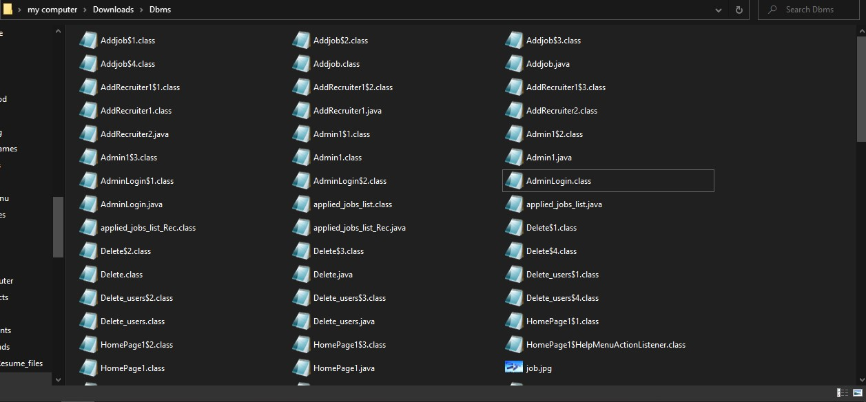

**Testing:**

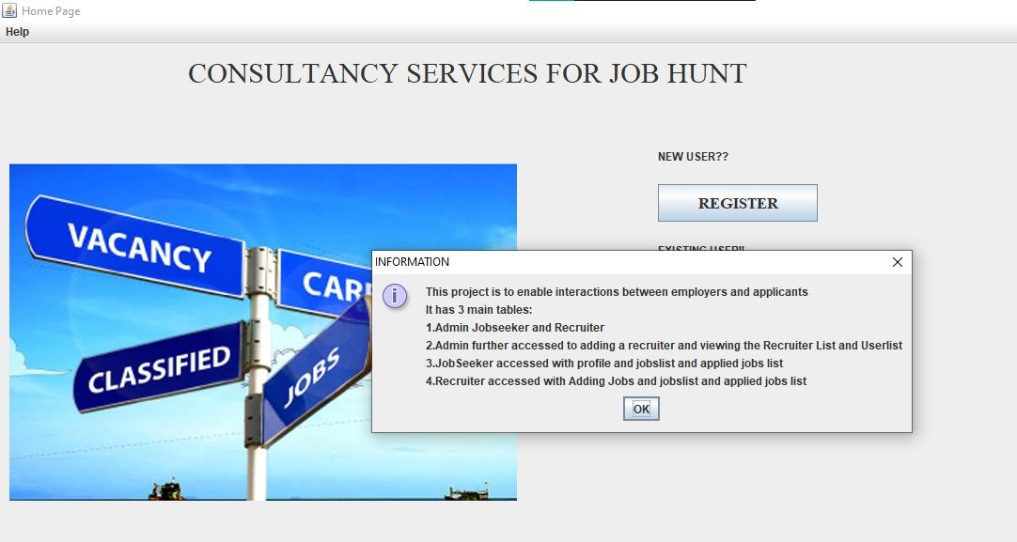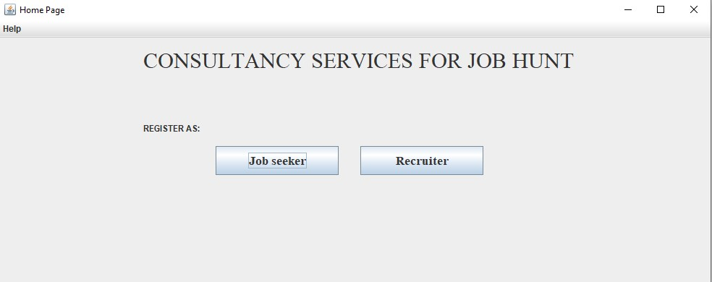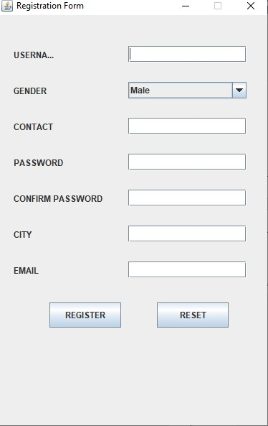

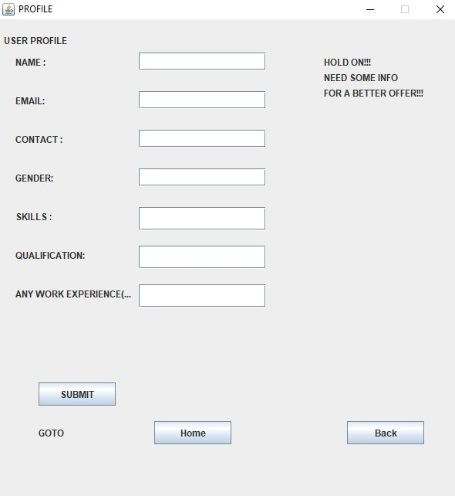

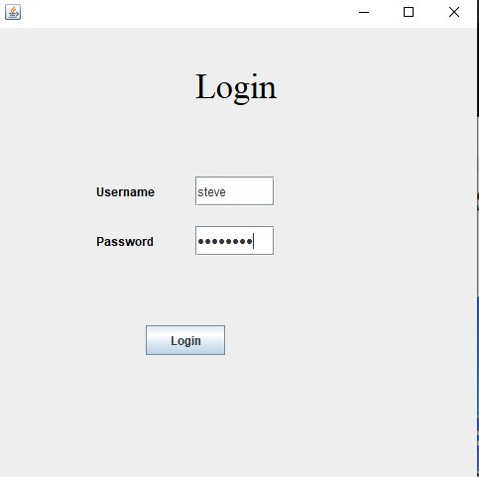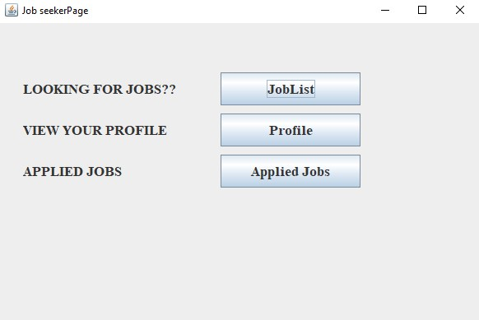

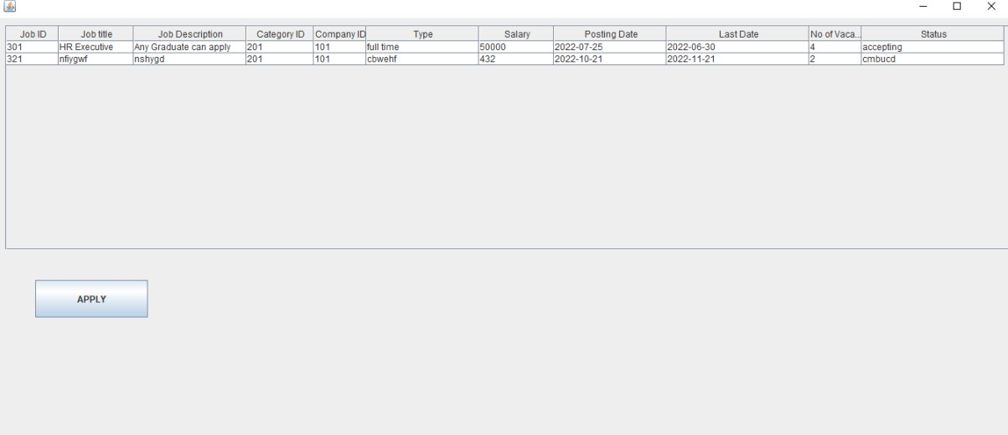

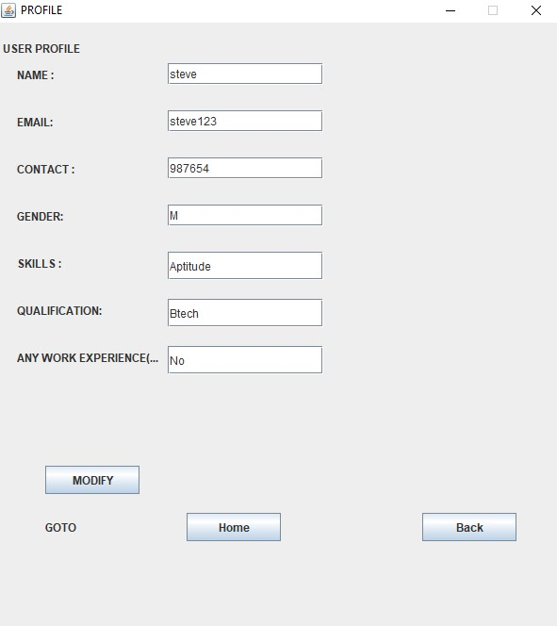

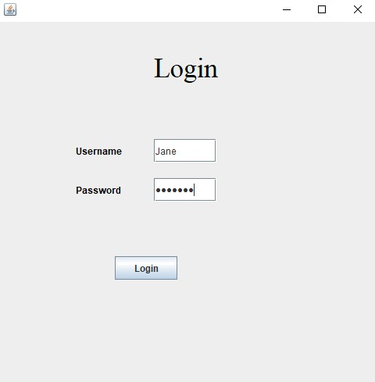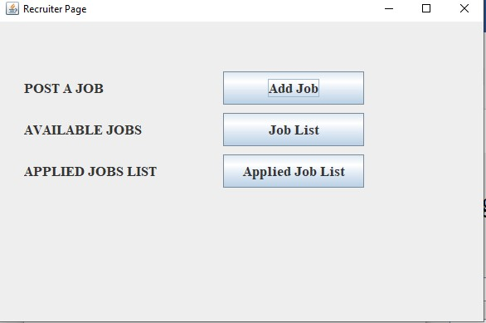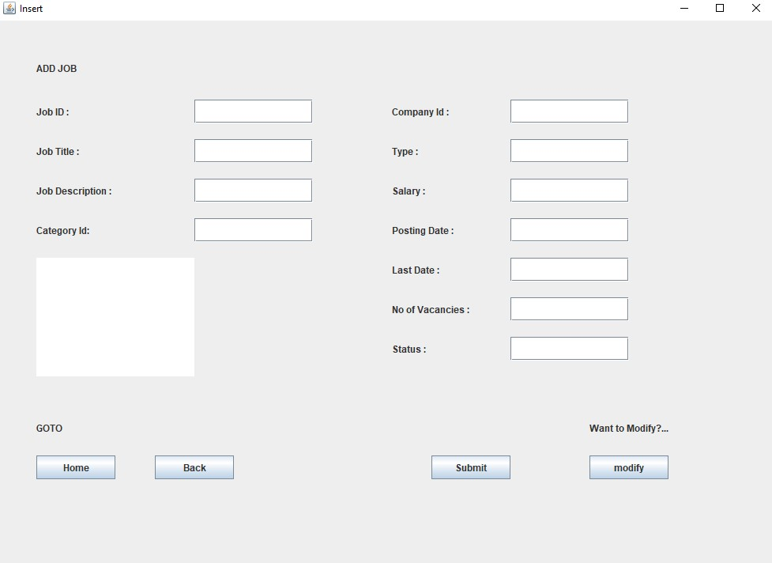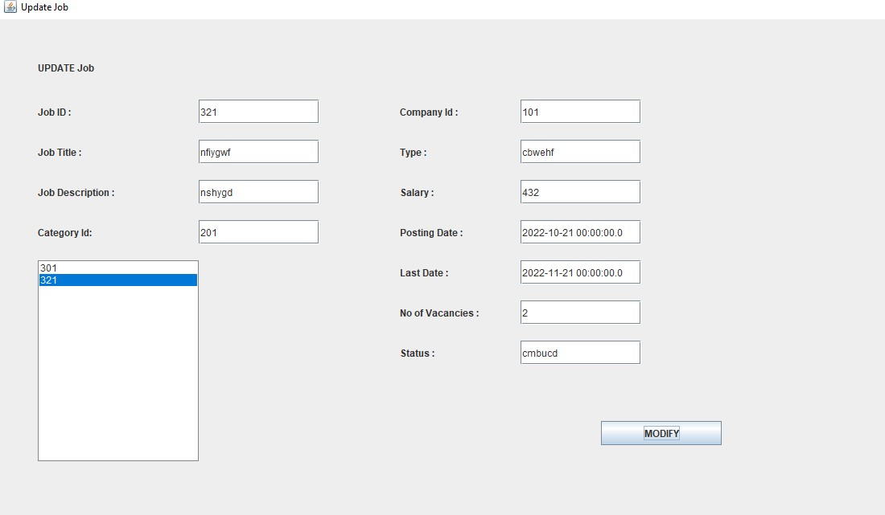

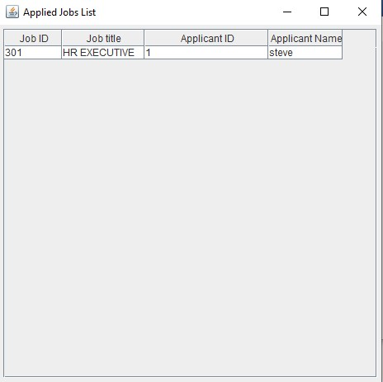

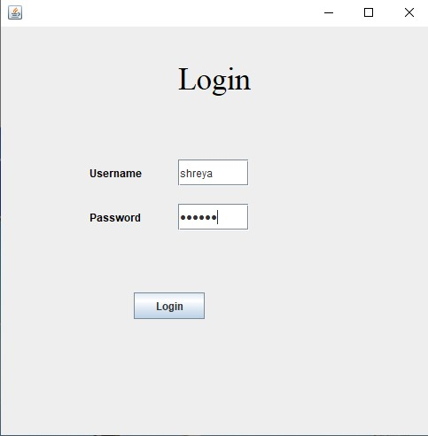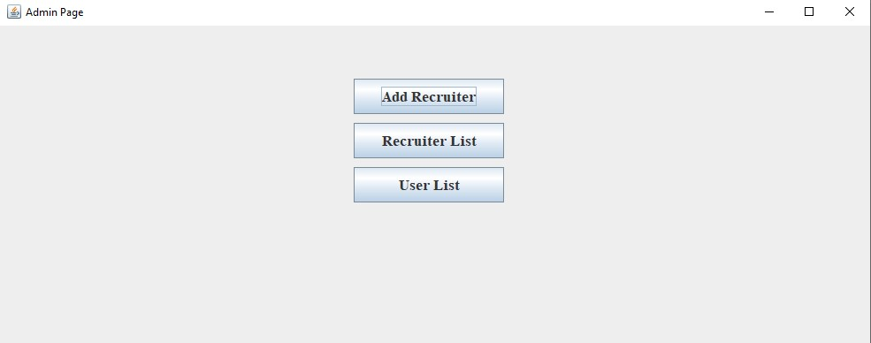

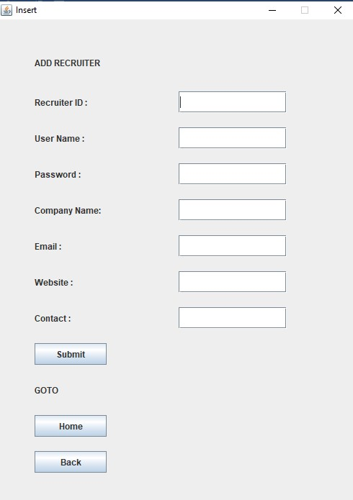

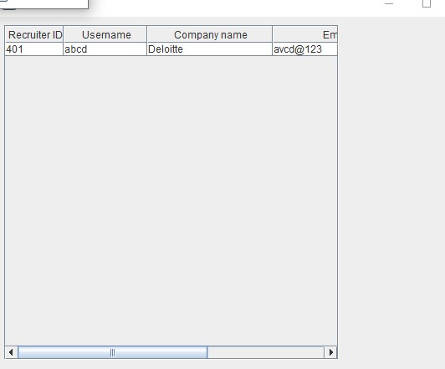

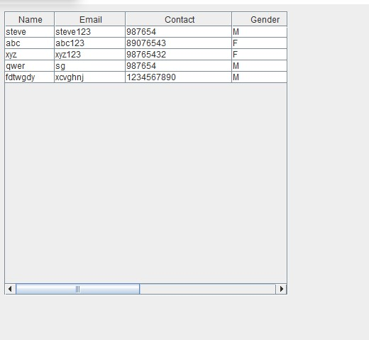

**Results:** I had successfully completed PROJECT on “CONSULTANCY SERVICES FOR JOB HUNT”

**Discussion and future Work:**

This application provides the Jobseekers to know about the information of available jobs in the city. In this application, it stores the information about the job details, jobseeker details and provides better job offers.

I also wanted this application to provide/conduct an online exam where jobseeker can test his/her skills and able to show him the feed related to his/her score.

**CONCLUSION:**

Thus, a Java SWING based ***CONSULTANCY SERVICES FOR JOB HUNT*** is created which is connected to the Oracle 11g database. Therefore, all the entries and details are directly updated on their respective tables created in the database